**Oban**

**Arnott’s House (Part of Isle of Eriska Hotel)**

**Friday May 29 – Saturday May 30 – 1 night**

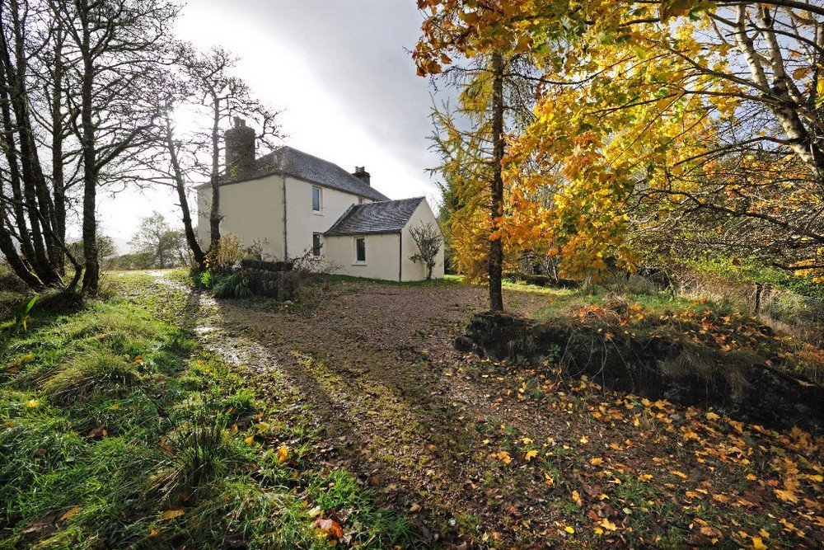

Enjoy an incredible break to the Scottish Isles with our luxurious holiday home, Arnott’s House. Located on the other side of the island from our Main House, you and your guests can truly unwind and feel like you have the entire island to yourself, surrounded by remote woodland area 50 metres above Loch Creran with stunning views towards Ben Cruachan.

Spread across 2 floors, our 3-bedroom luxury holiday home has more than enough space to comfortably fit 6 guests. Each room has its own en-suite facilities and can be arranged as either a double or twin room, depending on what you need. Each bathroom includes all the luxury amenities you might need, including a separate bath and shower.

Downstairs, you’ll find a separate kitchen and living/ dining area. The modern kitchen is fully equipped, and the living area or our large conservatory have fabulous views over your own private garden.

Similarly, there’s a covered boot room and drying area outside of the house where you can kick off your shoes.

We have a variety of rooms, suites, lodges, and cottages to choose from. All within walking distance of our Main House, Spa, and Restaurants.

For even more privacy, you can opt for our exclusive self-catering Arnott’s House, which is only a short drive from our Main House and is located on the east of the island.

Please note for accommodations outside of the Main House, transport is not provided.

Thoughtful touches

* Complimentary selection of Teas and Coffees
* Cosy bathrobes, slippers, and a hair dryer
* Luxurious Penhaligons toiletries
* Stunning terrace and garden with outdoor lounging furniture
* Fully equipped kitchen
* Bluetooth sound system
* Unlimited WiFi
* Private parking with walking paths down to the Main House

With such incredible amenities and location, this house is the perfect weekend escape from the city or a longer peaceful break.

Fire up the fun with your own private BBQ!

Sizzle up a memorable evening under the stars with our fantastic BBQ station. Arnott's House provides everything you need for a delicious and hassle-free grilling experience:

Prepped to Perfection: Choose from a selection of succulent steaks and marinated kababs, all ready to cook.

All the Fixings: We'll provide a variety of fresh salads, creamy coleslaw, and a bottle of wine to complement your BBQ feast.

£200 BBQ Package: This complete package includes all the above, perfect for a self-catered BBQ experience.